Module 8: Portfolio Project

Christian Johnson
Colorado State University Global
CSC-450-1: Programming III
Dr. Bindu George
September 13th, 2026

ConcurrencyCounter.java
public class ConcurrencyCounter {

public static void main(String[] args) {

Thread firstThread = new Thread(() -> {
System.out.println("Counting up starting here:");

for (int number = 0; number <= 20; number++) {
System.out.println(number);
}

System.out.println("Count up finished.");
});

Thread secondThread = new Thread(() -> {
System.out.println("Counting down starting here:");

for (int number = 20; number >= 0; number--) {
System.out.println(number);
}

System.out.println("Count down finished.");
});

firstThread.start();

try {
firstThread.join();
} catch (InterruptedException e) {
System.out.println("Thread interrupted.");
}

secondThread.start();

try {
secondThread.join();
} catch (InterruptedException e) {
System.out.println("Thread interrupted.");
}

System.out.println("Both countdowns complete.");
}
}

Programming Analysis
Performance Issues with Concurrency:
- Creating and managing multiple threads can add extra overhead to the program.
- My program uses join() so the second thread waits until the first thread finishes.
- Limiting unnecessary threads and only using concurrency when tasks can run at the same time can reduce performance issues.
Vulnerabilities with Strings:
- Java String objects are immutable, meaning their contents cannot be changed after creation.
- Sensitive information stored in a String could remain in memory until garbage collection removes it.
- My program only uses strings for console messages, so there is very little security risk in this application.
Security of Data Types:
- My program uses int values for the counters, which only range from 0 to 20.
- These values are far below the limits of a Java int, so integer overflow is not a concern in this program.
- The program does not accept outside user input, which reduces the risk of invalid or malicious data affecting the counters.
- If user input were added, validating the values before using them would help prevent security problems.

Application Execution:
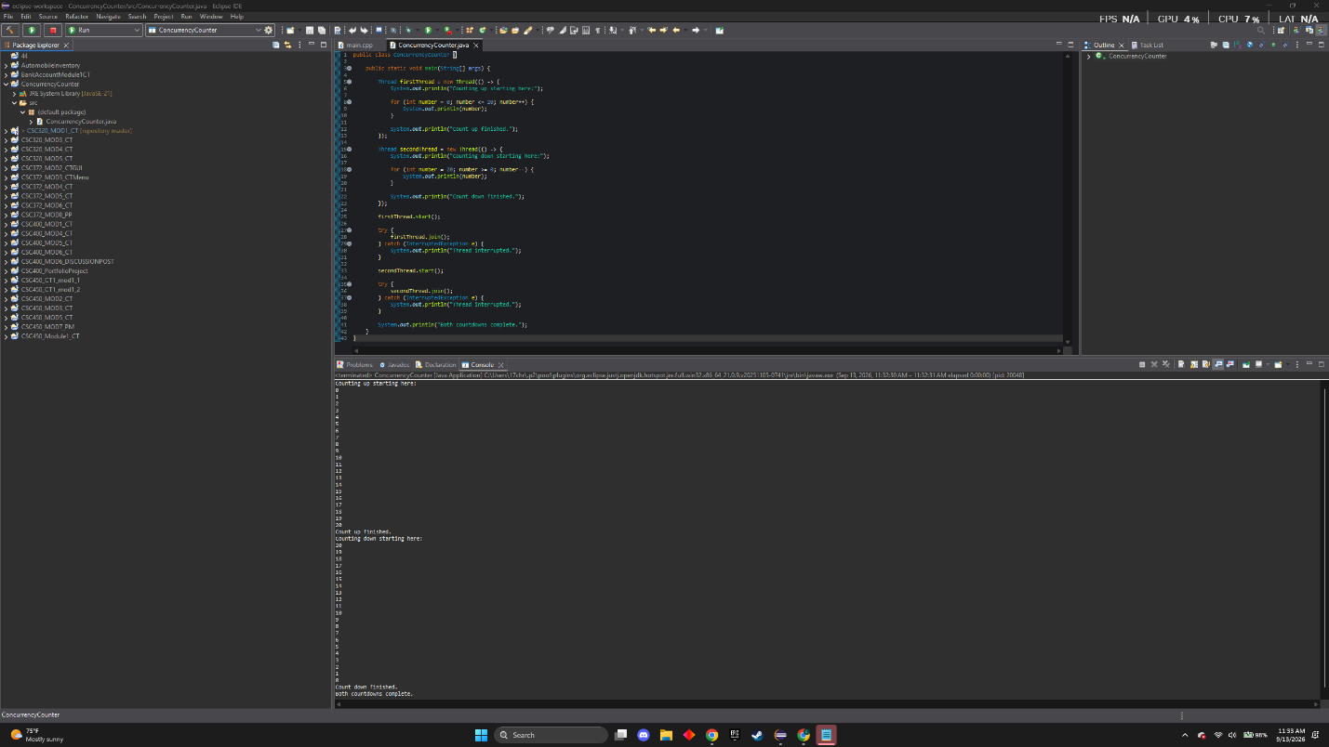

GIT Repository Link and screenshot:
https://github.com/17cjohnson/CSC450_MOD8_PP_CJ 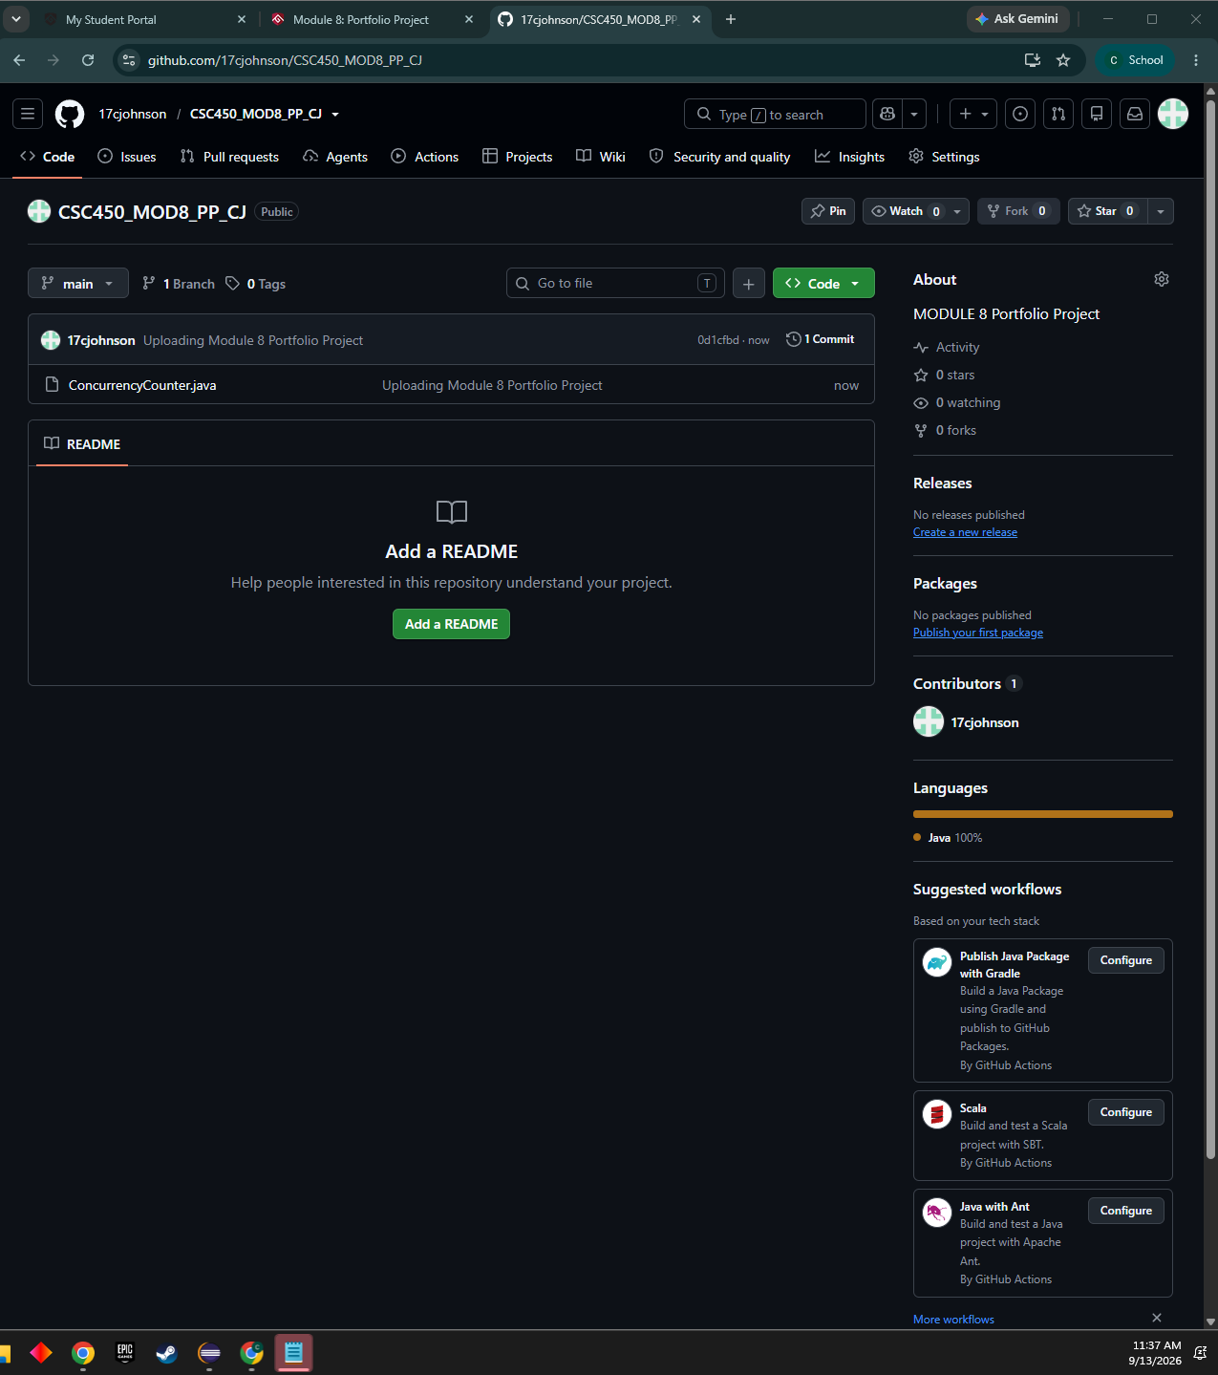

Java/C++ Comparison
Thread Comparison
My Java and C++ programs both use two threads to complete the same counting task. I wanted to keep the code as simple as possible in both languages because the task is only counting up and back down. I did not want to make either program more complicated than it needed to be just to show how the threads work. In the Java version, the first thread counts from 0 to 20 and the second thread counts from 20 back down to 0. The start() method starts each thread, and join() makes the program wait for a thread to finish. My C++ version works the same way generally. It also starts the first thread, waits for it to finish with join(), and then starts the second thread. Concurrency allows a program to work with multiple tasks during the same period of time, but that does not always mean the tasks are running at the exact same time (Raza, 2025). That is what happens in both of my programs because the second thread has to wait until the first one is completely done.
Performance Comparison
Concurrency does not really make either of my programs any faster. Creating and managing threads takes some extra work, and my programs are only counting up to 20 and back down again. For something this simple, I honestly think two normal loops would make more sense if the assignment was not specifically about demonstrating threads. Concurrency can improve performance and help a program make better use of computer resources when there are multiple tasks to work on (Raza, 2025). I can see this being much more useful in a larger program where different tasks actually need to run during the same period of time. C++ also gives the programmer more direct control, while Java uses the Java Virtual Machine to handle more things automatically. For the two programs I made, I do not think there would be much of a noticeable performance difference because the amount of work being done is so small.
String Comparison
There are also some differences in how Java and C++ work with strings. My Java program only uses strings for basic messages like "Counting up starting here," "Count up finished," and "Thread interrupted." I kept the messages basic because I really only needed them to show what the program was doing while it ran. There is no private information being stored in these strings, so they are not much of a security issue for my program. Java strings are immutable, which means they cannot be changed after they are created. If a Java string is changed, a new String object is created instead (Jeff, 2024). C++ strings can be changed after they are created, which is one difference between the two languages (Jeff, 2024). This difference does not really affect either of my programs, but I can see how it would matter more if the strings were holding passwords or other sensitive information instead of simple console messages.
Data Type Comparison
Both programs use integers for the actual counting. In my Java version, the int variable only needs to hold numbers from 0 to 20. These are very small values for an int, so integer overflow is not something I have to worry about with this program. The same is true for my C++ version because it is using the same basic numbers. I did not see any reason to use more complicated data types when a basic integer handles everything the counter needs. Another thing that makes both programs safer is that the user cannot enter their own values because all of the numbers are already set in the code. In a larger program choosing the correct data type could be much more important. A banking application dealing with large amounts of money would need data types that can safely handle the values being stored and calculated. If I added user input to my program I would also want to validate the values before using them to help prevent bad or unexpected data from causing problems.
Security Comparison
One of the bigger differences between Java and C++ is the amount of control the programmer has over memory. Java handles a lot of memory management automatically while C++ gives the programmer more direct control. Java was designed to prevent some problems that can happen in C and C++, including invalid memory references and accessing memory outside of the correct range (Marx, 2013). Java also uses garbage collection to help manage memory automatically. From a beginner standpoint, I like that Java handles more of this automatically because it gives me fewer things to worry about when writing a simple program. C++ gives the programmer more control which can help with performance, but the programmer also has more responsibility for handling memory correctly. My C++ counter program is pretty basic and does not use raw pointers or manually allocated memory, so those types of memory problems are not really an issue in my program. I would consider my Java version less vulnerable to certain memory problems, but I would not say Java is always safer than C++. Java can still have security problems if the program itself is written poorly, and the language being used is not the only thing that determines how secure a program is (Marx, 2013).
Conclusion
My Java and C++ programs do basically the same thing in two different languages. Both use two threads and join() to make sure the counting happens in the correct order. Neither gets much of a performance boost from concurrency because the second thread waits for the first one. I would consider my Java version less vulnerable to some memory problems, but both programs have a low security risk for this simple task.
References
Marx, D. (2013, August 26). Is Java riskier than C/C++? InfoWorld. https://www.infoworld.com/article/2159564/is-java-riskier-than-c-c.html
Jeff, J. (2024, March 28). Understanding string data types across C, C++, Java, and Python. Medium. https://medium.com/@juniajeff/understanding-string-data-types-across-c-c-java-and-python-f086b614dcd1
Raza, M. (2025, April 23). Concurrency in programming and computer science: The complete guide. Splunk. https://www.splunk.com/en_us/blog/learn/concurrency.html

